

Faculty of Applied Sciences  
Bachelor of Science in Computing

**COMP490 Final Year Project  
Weekly Status Report**Academic Year 2022/23

|  |  |
| --- | --- |
| Parsons problem generator and solver | |
|  |  |
| Project number: | 19 |
| Student ID: | P-19-0834-5 |
| Student Name: | Jane Liu |
|  |  |
| Supervisor: | Philip Lei |
| Assessor: | Charles Lam |

Table of Contents

1 Preliminary Project Work Plan 2

2 First semester W4-W14 3

2.1 Week 4 3

2.2 Week 5 3

2.3 Week 6 4

2.4 Gantt Chart 5

2.5 Week 7 6

2.6 Week 8 7

2.7 Week 9 8

3 Second semester W1-W13 10

3.1 Week 1 10

3.2 Week 2 (repeat up to Week 12) 10

3.3 Week 13 (Conclusion) 11

# Preliminary Project Work Plan

In this section, the preliminary project work plan submitted in the Project Proposal is attached. Progress in Week 4 – Week 6 can be checked against this work plan.

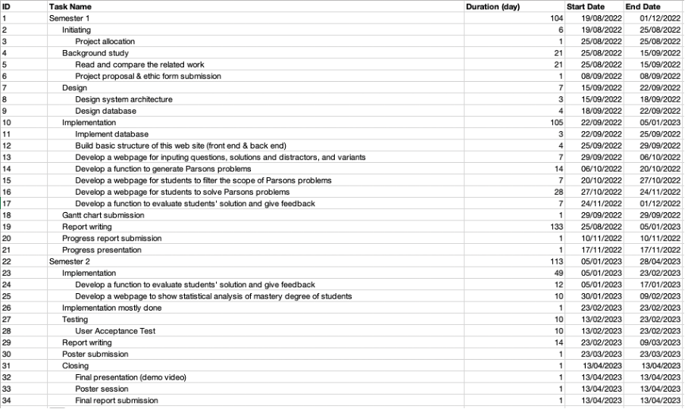

# First semester W4-W14

Starting from Week 4 of the first semester, this document should be updated every week to show the progress. In each weekly status report, the accomplished tasks and the plan for the coming week should be reported so that the supervisor can monitor the progress.

## Week 4

Report Date: 14/09/2022

### Tasks done this week

I read two papers about Parsons problem and I summarized some key points of these papers. By reading these papers, I found some gaps in the existing work and I picked up some new ideas about the specific use of Parsons problem in the questions about data structures and algorithms.

### Plan for next week

I plan to design the system architecture and database in the next week. Besides, I plan to study the specific question types in Data Structures and Algorithms to expand the use of Parsons problem in Data Structures and Algorithms.

## Week 5

Report Date: 21/09/2022

### Tasks done this week

I reviewed specific data structures and algorithms questions. Besides, I consolidated a paragraph to describe the discussion with the supervisor last week about using different algorithms in distractors. Furthermore, I built the basic structure of the front end. In the end, I designed the database.

### Plan for next week

I plan to implement the database and build the basic structure of this website. Besides, I plan to read more papers to get new ideas and enhance chapter 2 and chapter 3. Finally, I plan to draw the Gantt Chart.

## Week 6

Report Date: 29/09/2022

### Tasks done this week

I finished the Gantt Chart. Besides, I improved the old database design and I implemented database. Finally, I developed basic functions (add, edit, get, remove) of every entity.

### Plan for next week

I plan to read the textbook “Data Structures and Algorithms in Python” in detail to find more ideas in the following aspects: the summary of characteristics of some typical data structure questions, the difference between the questions of introductory programming course and the Data Structures and Algorithms course, the limitation of using previous Parsons problem in the Data Structures and Algorithms course because of the different characteristics of these two courses, the innovations of way to use Parsons problem.

## Gantt Chart

This section shows the first version of the Gantt Chart, as submitted in Week 6. It includes detail schedule for the project. The Gantt chart sets up the overall schedule for the whole project. Therefore, from Week 7 of the first semester onwards, progress should be checked with the Gantt chart.

The schedule in the Gantt Chart may be revised during the course of the project. This is necessary, for example, in case of risk mitigation. It is necessary to include the updated Gantt chart in the Weekly Status Report in a section like this one. Explain the reasons for schedule revision. It is also necessary to adopt a sound method of version control to avoid potential confusion regarding which version is currently being used.

Modified Date: 29/09/2022

Gantt Chart is included below



## Week 7

Report Date: 06/10/2022

### Tasks done this week

I analysed the question types in Data Structures and Algorithms in detail. Besides, I analysed the limitation of previous work and design new way to use Parsons problem. Finally I summarized the previous two points in a draft report.

### Progress check against Gantt chart

Against Gantt chart, the present progress is slightly behind schedule. According to Gantt chart, I was supposed to begin implementation in this week instead of staying in design period. Thus, in the future, more effect should be put in quickening the implementation period.



### Plan for next week

I plan to consolidate the whole design based on all previous discussions. Besides, I plan to explore new ideas to make the recursion questions, the tree questions and the abstract class questions be easier for students to learn by using Parsons problem. Moreover, I plan to update the database structure to fit the new design. Finally, if the design blueprint is good enough for a project, I will begin implementation (developing a webpage for inputting questions with some additional parts)

## Week 8

Report Date: 13/10/2022

### Tasks done this week

I wrote some material for chapter 1 and chapter 2.

### Progress check against Gantt chart

Against Gantt chart, the present progress is slightly behind schedule. According to Gantt chart, I was supposed to begin implementation in this week instead of staying in design period. Thus, in the future, more effect should be put in quickening the implementation period.



### Plan for next week

I plan to finish the draft material for chapter 3. Besides, I plan to explore new ideas to make the recursion questions, the tree questions and the abstract class questions be easier for students to learn by using Parsons problem. Moreover, I plan to update the database structure to fit the new design. Finally, I plan to finish the implementation about inputting questions and generating Parsons problem.

## Week 9

Report Date: 20/10/2022

### Tasks done this week

I wrote the limitation of previous Parsons problem. Besides, I updated database design. Finally, I wrote a mind map of new ideas.

### Progress check against Gantt chart

Against Gantt chart, the present progress is slightly behind schedule. According to Gantt chart. In the future, more effect should be put in quickening the implementation period.



### Plan for next week

I plan to finish the draft material for new ideas. In addition, I plan to finish the implementation about inputting questions and generating Parsons problem.

## Week 10

Report Date: 27/10/2022

### Tasks done this week

I implemented several functions of the prototype of Parsons problem including inputting question and cutting solution. In addition, I wrote the draft materials for new ideas.

### Progress check against Gantt chart

Against Gantt chart, the present progress is slightly behind schedule. According to Gantt chart. In the future, more effect should be put in quickening the implementation period.



### Plan for next week

I plan to finish the draft material for new ideas. In addition, I plan to finish the implementation of the prototype.

## Week 11

Report Date: 27/10/2022

### Tasks done this week

I finished the problem analysis parts in the Chapter 3 of the Progress Report.

### Progress check against Gantt chart

Against Gantt chart, the present progress is slightly behind schedule. According to Gantt chart. In the future, more effect should be put in quickening the implementation period.



### Plan for next week

I plan to finish Chapter 1, Chapter2 and Chapter 3 of the Progress Report. In addition, I plan to finish the implementation of the prototype. Besides, I plan to finish parts of Progress Presentation of showing examples.

# Second semester W1-W13

## Week 1

Report Date: dd/mm/yyyy

### Tasks done this week

List what tasks you’ve accomplished in this week.

### Progress check against Gantt chart

Use the Gantt chart to evaluate your progress.

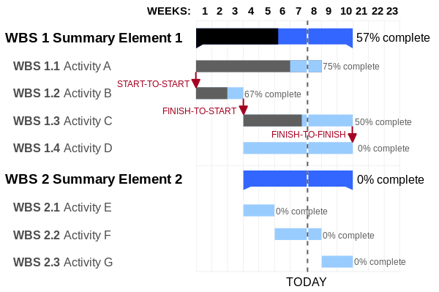

### Plan for next week

List the tasks you plan to do in the next week. In case you’re behind schedule, describe what you will do to catch up.

## Week 2 (repeat up to Week 12)

Report Date: dd/mm/yyyy

### Tasks done this week

List what tasks you’ve accomplished in this week.

### Progress check against Gantt chart

Use the Gantt chart to evaluate your progress.



### Plan for next week

List the tasks you plan to do in the next week. In case you’re behind schedule, describe what you will do to catch up.

## Week 3

Report Date: 01/02/2023

### Tasks done this week

Update database: add ‘Type’ attribute in ‘Question’, ‘Solution’, ‘Block’, and ‘Fragment’ Entity; delete ‘Feedback’ Entity and add ‘Reason’ in ‘Distractor’

Add function: input question name, input question type, upload multiple solution and store the solution sequence in question; customize single solution: input solution type, input distractor, input difficulty level information, input block information

Explore: new store answer sequence => problems: can not only check the block in level when comparing with the original file directly; 2D answer pool => grid, nested draggable, pre-set empty horizontal line places to have a fake 2D view => not have result yet

### Progress check against Gantt chart

Use the Gantt chart to evaluate your progress.



### Plan for next week

List the tasks you plan to do in the next week. In case you’re behind schedule, describe what you will do to catch up.

## Week 4

Report Date: 08/02/2023

### Tasks done this week

Redesign the description of various ‘Type’, Gather them most in the ‘Type’ in ‘Question’, Make it more user friendly, Update ‘Type’ in database

Implement 2D view answer pool

Classify different types of feedback in the program

Add input question type page

### Progress check against Gantt chart

Use the Gantt chart to evaluate your progress.



### Plan for next week

List the tasks you plan to do in the next week. In case you’re behind schedule, describe what you will do to catch up.

## Week 5

Report Date: 15/02/2023

### Tasks done this week

Redesign the description of various ‘Type’, Gather them most in the ‘Type’ in ‘Question’, Make it more user friendly, Update ‘Type’ in database

Implement 2D view answer pool

Classify different types of feedback in the program

Add input question type page

### Progress check against Gantt chart

Use the Gantt chart to evaluate your progress.



### Plan for next week

List the tasks you plan to do in the next week. In case you’re behind schedule, describe what you will do to catch up.

## Week 6

Report Date: 23/02/2023

### Tasks done this week

Fix Bugs about context, insert key code, compare algorithm

Modify user interfaces of context, multiple steps

Calculate score and store it in record

Implement different difficulty level

Implement home page

Implement login and register

Implement half of personal center

### Progress check against Gantt chart

Use the Gantt chart to evaluate your progress.



### Plan for next week

List the tasks you plan to do in the next week. In case you’re behind schedule, describe what you will do to catch up.

## Week 7

Report Date: 02/03/2023

### Tasks done this week

Fix Bugs about context icon, improper check context or insert key code result, placeholder, left arrow indention check wrong, admin not have right to upload, customize easier solution not work.

Concrete example

Write chapter 3

### Progress check against Gantt chart

Use the Gantt chart to evaluate your progress.



### Plan for next week

List the tasks you plan to do in the next week. In case you’re behind schedule, describe what you will do to catch up.

## Week 13 (Conclusion)

Report Date: dd/mm/yyyy

### Tasks done this week

List what tasks you’ve accomplished in this week.

### Progress check against Gantt chart

Use the Gantt chart to evaluate your progress.

